**Design and Development of Brain-Computer Interface (BCI) for Navigating Drones**

Final Year Project Proposal

by

**Muhammad Raheal Safdar**

**Madiha Ansari**

**Naneeta Talreja**

**___________________________________**

**Supervisor:**

Dr. Ahsanullah Abro

____________________________________

**Co-Supervisor:**

Dr. Ahmed Ali Shah

Sir Riaz Afridi

Sukkur IBA University  
Computer Science Department

(2022)

**Abstract**:

The Brain Computer Interfaces (BCIs) are extensively researched as an emerging area of the studies in the field of Human Computer Interaction (HCI). It is understood that the different optimal location for the Brain Computer Interface (BCI) is at the intersection of the humans and machine adaptability. An electroencephalogram (EEG) headset could be put on the user's scalp, where, the non-invasive BCI decodes brain signals to detect and translate the user's neural actions and activities. It is observed that drones are now widely employed for a variety of reasons, including military services, weight lifting, cinematography, photography, and cargo delivery. The several breakthroughs and contributions have also been presented in the BCI-based drone control system in various domains according to their usefulness and applications. However, there is a lack of navigational cues to detect user’s brain signals and to translate them into expected actions and activities accurately. It leads to an inappropriate control of drones for different applications. Thus, it is aimed to design and develop a BCI that could be attributed with a set of navigational cues to control drones in three-dimensional (3D) physical space. Users may be able to control a flying robot (also termed as a drone or UAV) in six directions using non-invasive scalp electroencephalogram (EEG) on human subjects. Those six directions include up, down, left, right, forward, and backward. The EEG is a method that helps in detecting and recording an electrogram of electrical activity on the scalp, which has been shown to represent the macroscopic activity of the brain's surface layer underneath. The proposed BCI may contribute in making life easier for normal as well as people with special needs such as stroke patients (paralyzed) or having difficulty with the motor images. People may control a drone with their minds alone, and also may require no physical action.

**Contents**

**1.0 Introduction:** 4

**2.0 Literature Review:** 5

**3.0 Problem Statement:** 7

**4.0 Project Goals:** 7

**5.0 Proposed Solution:** 7

**6.0 System Architecture:** 7

**7.0 Project hardware and software tools:** 9

**8.0 Modules and their deliverables:** 10

**9.0 Project Budget:** 10

**10.0 Methodology:** 11

**11.0 Project milestones and deliverables:** 12

**12.0 Conclusion:** 12

**References:** 13

# **1.0 Introduction:**

As per the year 2011, World Health Organization (WHO) global report [1] on disability says that one out of every five individuals on the planet Earth is disabled. This worldwide estimate is rising due to the aged people and the fast spread of chronic illnesses. Many of these persons have neuromuscular diseases such as amyotrophic lateral sclerosis (ALS), spinal cord damage, brainstem stroke, and other conditions that cause voluntary muscle control to be lost [2]. These people are typically confined to a wheelchair or a bed. They are unable to move their muscles or can’t go anywhere they want. They have significant obstacles in modern society as a result of their limits and disability to perform basic activities such as playing games with others or conversing with the people. These activities are essential for personal growth and have a significant influence on one's quality of life. Those who lack motor skills might benefit greatly from devices that increase movement. In recent years, cutting-edge technology such as the Brain-Computer Interface (BCI) has been more widely available to the general public, and it is our moral obligation to use such technologies to eliminate these barriers and allow disabled persons to resume a normal life. BCI combines brain and machine integration, with both using the same interface to provide a communication channel between the brain and an externally controlled item. The neural network of the human brain is made up of interconnected clusters of neurons that are responsible for the transfer of information. Hans Berger, a German psychiatrist, was the first to quantify brain waves using electroencephalography, a method for recording brain waves, in 1924 [3]. The EEG equipment, which collects the brain waves produced by neurons and transmits them to a computer, which then converts the signals into data [3], is an example of this technology. This information is transformed into commands for a computer-connected device. Electrodes are used to evaluate brain electrical activity using the Emotiv EPOC headset.

Delta, Beta, Theta, Alpha, and Gamma are some of the several packs that make up EEG signals. Each pack corresponds to a different sort of mental activity [4]. The strength of these bands is periodically changed during the day. The strength of distinct EEG bands is really related to the brain's activity and state of consciousness [2].

A lot of study has been done in this field in recent years, with researchers seeking to build user-friendly and easy-to-use assistive technology for drone piloting. The purpose of our project is to develop a BCI system that controls the drone's motions using the Tello EDU Drone and human brainwaves.

The following section describes the literature review of previous work on Drone navigation with EEG, problem statement, project goals, proposed method of controlling the drone using human brain waves, architecture of the system, project hardware components used, modules and their deliverables, project budget, methodology, and timeline. The last part contains the conclusion.

# **2.0 Literature Review:**

The focus at work [1] was to control the drone using facial expressions and mental commands to guide it in six different directions (left, right, up, down, forward and backward). The EEG headset used to collect the brain signals was the Emotional Insight (5-channel) and the Parrot Mambo Fly drone was used for the experiment. The accuracy of the tests was 88%, based on the correctness of mental instructions, which indicates how attentive the person is during the test. Signals from the headset are carried to the computer via Bluetooth, and signals from the computer to the raspberry-pi zero microcontroller are sent with the help of Message Queuing Telemetry Transport (MQTT) protocol, which is also used for communication between the drone and the raspberry-pi zero. Emotiv Cortex and the python-3 was used to make the software program. This software allows communication between the computer and the headset.

The EEG headset used to collect brain data was the Emotive EPOC headset (16 channels), and the quadcopter AR 2.0 drone was used for the experiment in the study [2]. The author recovered facial features such as left/right smile, frown and left/right wink. A tablet-based mobile framework based on the Android OS will be created to convert observed patterns into instructions that can be used to control the quadcopter AR 2.0 drone through any wireless medium. The system design includes a signal processing unit, the Emotiv engine development kit and the Emotiv API.

The approach was a fully independent BCI multiclass system based on the Steady-State Visual Evoked Potential (SSVEP) paradigm that is capable of moving the drone in six directions that are up, down, left, right, forward and backward. The EEG headset used to acquire the signals brain cells was the Emotiv COPD Neuroheadset (16 channels), and the drone was replaced for the experiment by a feedback loop using LEDs that are controlled by an Arduino board. The BCI system was tested on ten healthy controls and gives an accuracy of 92.5% on average. The data obtained from the EEG headset is sent to a desktop using Bluetooth and a USB adapter. A Python script was created and implemented to acquire and decode the EEG raw data signal. MATLAB was used to perform methods like signal processing, feature extraction and classification.

The study methodology [4] specifies four motor imagery tasks that need to be worked on. The first task is to imagine a movement with the left hand without moving the hands. Task 2 is similar to Task 1, but is done with the right hand. Task 3 asks the patient to imagine movements with the left hand, fingers, and elbows. Task 4 is similar to Task 3, but is done with the right hand. For the

experiment, an Emotiv Inc. headset was used. EPOC+EEG, which provides 14-lead EEG data, and a Parrot 2 AR drone. For the calculation, a dual dataset is applied to the constructed model. The

Python-based algorithm runs on a ground station in continuous duplex communication with the UAV over Wi-Fi.

The inactivity or execution of another movement in which no action is performed is described in the work [5], as well as the blink of the left eye to move in the negative direction of the selected axis, the blink of the right eye to move in the positive direction, the direction of the selected axis, raise your eyebrows to select the axis of movement and idle or perform another movement that does not perform an action. For this experiment, a 16-lead EEG headset was paired with a Parrot Mambo drone. Subjects of both sexes, aged between 18 and 30 years, provided recordings for training classifiers. According to the system, the best performing classifiers are RF (with the data filtered at alpha rate and then scaled between zero and one), which achieves an accuracy of almost 85%, and the CNN network (with filtered data). at the alpha rate), which achieves an accuracy of 86.66%. The program to connect the drone to the BCI modules and classifier is written in Python, using PyQT5 for the interface, pyOpenBCI to connect to the BCI modules and pyparrot for the drone connection and commands.

The aim of the study [6] was to develop an innovative Brain Computer Interface (BCI) system that responds to patients' brain activity and sends a signal to the aircraft telling it to fly in four different directions (up, down, left, right). The Emotiv EPOC helmet (16 wires) was used to collect brain data and a custom quadrotor drone was deployed for the experiment. After just 10 minutes of training, a 52% success rate was achieved by completing a task on time. EEG headset data is transmitted to a laptop via Bluetooth and signals from the laptop to the drone are sent via TCP/IP protocol. A C# software application was created to capture and decode the EEG raw data signal, while two C applications were written. The first software is for the server and resides on the PCB, while the second program is for the client and resides on the Printed Circuit Board (PCB).

The authors of the article [7] proposed a method in which they trained four different mental tasks, one for each direction of drone control: ascending mental task for takeoff, descending mental task for decreasing altitude, right mental task for the movements of the drone. right side head and left turn in mental task for left side head movements. The Emotiv Insight headset (7 channels) was used to collect brain signals, while the Parrot Rolling Spider drone was used for the experiment. EEGLAB was used as a programming environment that was used to store, measure, manipulate and to access the EEG data that was gathered through the experiments.

# **3.0 Problem Statement:**

As mentioned before, in recent years, a lot of research has been done in this subject, with researchers attempting to develop user-friendly and easy to use assistive technology for drone navigation. BCI will be the new horizon as an assistive technology being used for drone navigation. However, there is a lack of navigational cues to detect user’s brain signals and to translate them into expected actions and activities accurately.

# **4.0 Project Goals:**

The main goal of our project is to design and develop BCI system that will:

1. Establish one-way communication from brain signals to desktop application running on our laptop.
2. Open up the communication between the Drone and the desktop application.
3. Control drone navigation in 3D space.

# **5.0 Proposed Solution:**

We will be having a dedicated system which will have the following specifications:

1. Brain Signal acquisition using EEG headset and transfer them to computer.
2. Preprocessing these signals to extract out such signals that are related to our specified directions.
3. Using those signals to build any Machine Learning model to give input to drone.
4. Controlling the drone navigation using those generated inputs from our model via any Wi-Fi technology.

# **6.0 System Architecture:**

The proposed system will have the following architecture: starting with the headset, Emotiv EPOC will be used for brain signal acquisition from subject’s mind scalp from different channel locations as shown in Figure 1 and will be transferred to computer via Bluetooth. The signal will be received by the Emotiv software provided by the Emotiv incorporation that allows you to view your EEG data, interpret your results and creates a window into your brain like never before. We will build a desktop application in C# that will act as intermediator between brain and drone. This application will be accountable for receiving raw signals from Emotiv software, applying preprocessing on the signals and will use ML model for signal classification.

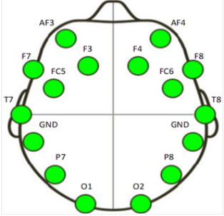

Figure 1 Location of the sixteen channels by Emotiv EPOC

The ML model is the "object" that remains after a machine learning algorithm is applied to training data, and it contains the rules, numbers, and other algorithm-specific data structures that are required to create predictions. The desktop application will generate an output command that will act as an input for the drone and these signals will be transferred to drone via wi-fi. The drone we will be using is Tello EDU. The Drone is programmed in python and can be attached to desktop, laptop or remote controller using the Wi-Fi technology.

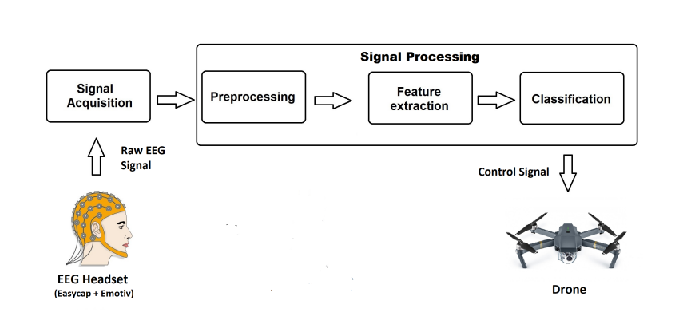

Figure 2 Proposed System Architecture

# **7.0 Project hardware and software tools:**

Following devices will be used in our project, which will be provided by the institution:

1. 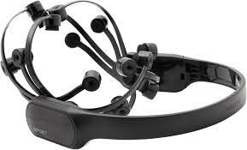Emotive (EPOC) EEG Headset

Figure 3 EEG Headset (Emotiv EPOC)

1. Tello EDU Drone

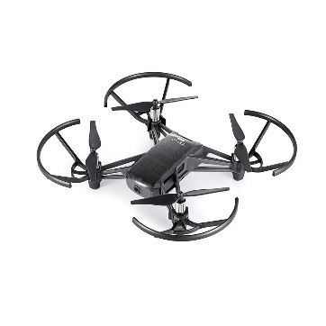

Figure 4 Tello EDU Drone

Following are the tools that we will use in order to make the system:

1. EMOTIV Software
2. Visual Studio (.NET Framework)
3. Programming Simulator for Drone
4. Python
5. C Sharp

# **8.0 Modules and their deliverables:**

|  |  |
| --- | --- |
| **Modules** | **Deliverables** |
| Extracting the brain signals through EEG | Desired signals to generate commands. |
| Desktop Application for preprocessing and ML model training | Fully working Desktop Application |
| Commands from Desktop Application to control Drone Navigation | Drone Navigating in 3D space using brain signals |

Table 1 Modules and their deliverables

# **9.0 Project Budget:**

Following is the estimated cost of required hardware and licensed software for the project:

|  |  |
| --- | --- |
| **Required Component** | **Estimated Price** |
| Emotiv EPOC headset | Rs. 159000/- Approx. |
| Emotiv annual licensing | Rs. 66000/- Approx. |
| Other Software and hardware components | Rs. 10000/- Approx. |
| Total Cost | Rs. 235000/- Approx. |

Table 2 Project Budget

# **10.0 Methodology:**

There are no strict requirements for the system, we will prefer to employ Agile technique for our system. Agile is a software development process in which the entire project is split down into small pieces and each developer works on their own piece while collaborating with stakeholders and other developers. Clients explain the end product they require, together with the functionalities they require, using this manner. Changes in specifications are readily accepted and applied here, resulting in a speedier delivery of the final product, which can be adjusted further. A planning, executing, and assessing cycle exists. This is continued iteratively, with additional needs added, until a product generation that is more acceptable to the client is discovered at the end.

The four primary values are written as follows:

1. Processes and tools vs. people and their interactions.
2. Working software prioritizes over detailed documentation.
3. Rather than contract discussions, clients should collaborate with you.
4. Planned adaptation to change.

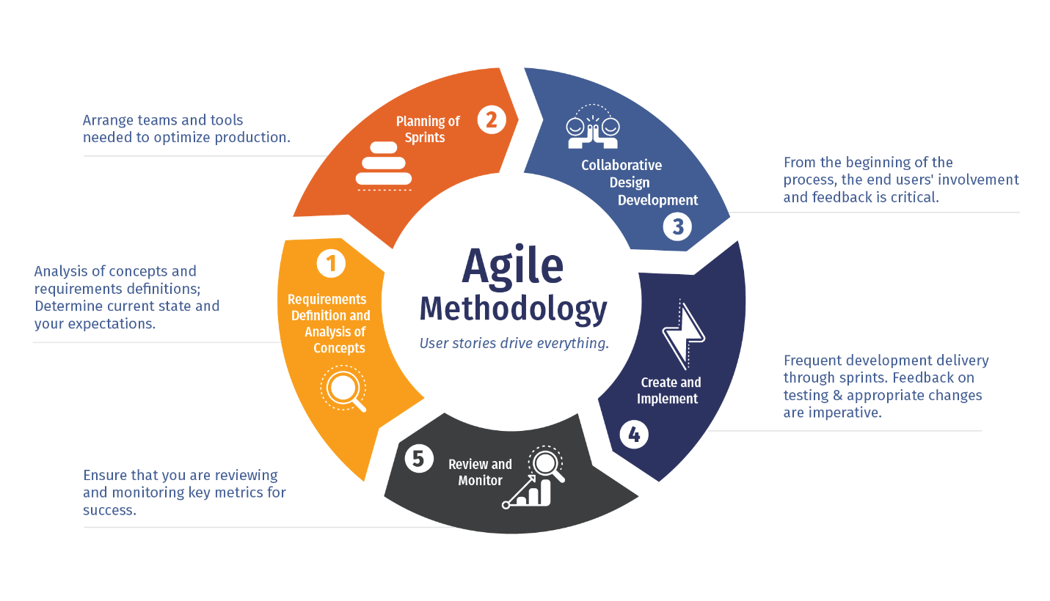

Figure 5 Methodology

# **11.0 Project milestones and deliverables:**

This project is expected to start from March 2022 and end till January 2023.

|  |  |  |  |  |  |  |  |  |  |  |  |
| --- | --- | --- | --- | --- | --- | --- | --- | --- | --- | --- | --- |
| **Activity** | **2022** | | | | | | | | | | **2023** |
| **Mar** | **April** | **May** | **June** | **July** | **August** | **Sep** | **Oct** | **Nov** | **Dec** | **Jan** |
| **Literature Review (LR)** |  |  |  |  |  |  |  |  |  |  |  |
| **Problem Identification** |  |  |  |  |  |  |  |  |  |  |  |
| **System Requirements Specification** |  |  |  |  |  |  |  |  |  |  |  |
| **System Design Specification** |  |  |  |  |  |  |  |  |  |  |  |
| **System Development** |  |  |  |  |  |  |  |  |  |  |  |
| **System Testing** |  |  |  |  |  |  |  |  |  |  |  |

# **12.0 Conclusion:**

The Brain Computer Interfaces (BCIs) are extensively researched as an emerging area. It is aimed to design and develop a BCI that could be attributed with a set of navigational cues to control drones in three-dimensional (3D) physical space. The ultimate goal of this project was to design and develop a fully autonomous, user friendly BCI system that would help the disable people in the drone control in a three-dimension (3D) space via the power of their thoughts. Our technology intends to improve people’s quality of life by allowing them to interact with their environment.

# **References:**

1. Wolpaw, J.R., et al., *Brain–computer interfaces for communication and control.* Clinical neurophysiology, 2002. **113**(6): p. 767-791.

2. MARIN, I., M.J.H. ALBATTBOOTTI, and N. GOGA, *Drone Control based on Mental Commands and Facial Expressions.*

3. Millett, D., *Hans Berger: From psychic energy to the EEG.* Perspectives in biology and medicine, 2001. **44**(4): p. 522-542.

4. Placidi, G., et al., *Basis for the implementation of an EEG-based single-trial binary brain computer interface through the disgust produced by remembering unpleasant odors.* Neurocomputing, 2015. **160**: p. 308-318.

5. Lin, J.-S. and Z.-Y. Jiang, *Implementing Remote Presence Using Quadcopter Control by a Non-Invasive BCI Device.* Computer Science and Information Technology, 2015. **3**(4): p. 122-126.

6. Chiuzbaian, A., J. Jakobsen, and S. Puthusserypady, *Mind Controlled Drone: An Innovative Multiclass SSVEP based Brain Computer Interface.* 2019: p. 1-5.

7. Vishwanath, R.M., S. Kumaar, and S.N. Omkar, *A Real-time Control Approach for Unmanned Aerial Vehicles using Brain-computer Interface*.* 2018.

8. ∗, I.D.V., J.R.C. ∗, and C.A.P.C. *, *Recognition and Characteristics EEG Signals for Flight Control of a Drone.* 2021.

9. Alshbatat, A.I.N., L. Dong, and P.J. Vial, *AirServer: a Mind-Controlled Assistive Quadrotor Drone Aided by an Intelligent Fuzzy PD Controller.* 2016.

10. Rosca, S., et al., *Quadcopter control using a BCI.* IOP Conference Series: Materials Science and Engineering, 2018. **294**: p. 012048.